**LEBANESE AMERICAN UNIVERSITY**

**USAID – HIGHER EDUCATION SCHOLARSHIP PROGRAM**

**HES - Volunteering Program Verification Form**

This form is to be used to document volunteering hours. If a student volunteers for multiple organizations, a separate form must be used for each organization. **This form must be turned in by the 28th of each month, the latest.**

I certify that the scholar Rana Ayman El-Achkar completed a total of 5 hours of service at InnovaThrive.

The hours were completed hours as per the below:

Hours # 0 (date) _2/12 – 6/12_ (initials of supervisor) __A.K.___

Hours # 0 (date) _9/12 – 13/12_ (initials of supervisor) __A.K.___

Hours # 0 date) _16/12 – 20/12 (initials of supervisor) __A.K.___

Hours # 5 date) _23/12 - 27/12 (initials of supervisor) __A.K.___

Brief description of the activities the scholar performed or participated in:

Research Task - Academics (Blockchain for Ethical Mineral Sourcing)

Written feedback about the scholar’s performance:

Rana demonstrated a keen understanding of blockchain technology and its ethical applications. Her ability to synthesize information and present sustainable solutions highlights her analytical and strategic thinking skills

Please rate the overall performance of the scholar at your organization:

|  |  |  |  |
| --- | --- | --- | --- |
|  | Mastery (5) | Proficient (3) | Emerging (1) |
| **Problem solver** | X |  |  |
| **Engaged & Committed** | X |  |  |
| **Open-minded & multicultural** | X |  |  |

Signature

& stamp

__________________________

_

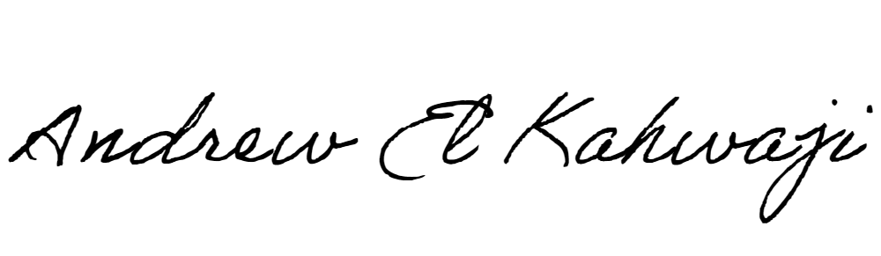

Printed Name _Andrew El Kahwaji_

Date __26/12/2024___

Email __andrew.lifesculptor.coo@gmail.com __

Phone __+961 71 914 378__